**2023 Year 11 Activity Survey Analysis**

Maidenhill School

**Meeting the Duty to participate**

|  |  |  |
| --- | --- | --- |
| **Participation Level** | **Number of Pupils** | **%** |
| **Not Participating** | 5 | 4.67% |
| **Working Towards Participation** | 1 | 0.93% |
| **Meeting the Duty to Participate** | 101 | 94.39% |
| **Grand Total** | **107** | **100.00%** |

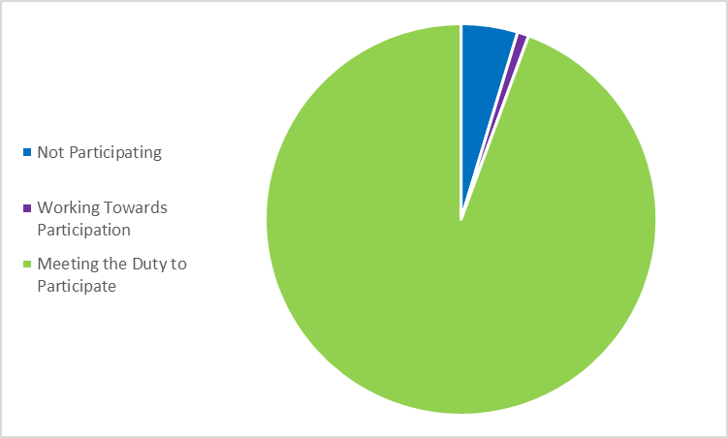

**List of Destinations**

|  |  |  |
| --- | --- | --- |
| **Activity Description** | **Number of Pupils** | **%** |
| Apprenticeship | 2 | 1.87% |
| Employment with training (other) | 1 | 0.93% |
| ESFA funded work-based learning | 1 | 0.93% |
| Further education | 87 | 81.31% |
| Re-engagement provision | 1 | 0.93% |
| School sixth-form | 11 | 10.28% |
| Seeking employment, education or training | 4 | 3.74% |
| **Grand Total** | **107** | **100.00%** |

