
Welcome to Impact Food Group – your school caterers.
We are delighted to be working in partnership with Maidenhill School to provide fresh, nutritious, and exciting meals for your children every day. Thank you for your ongoing patience and support as we establish and improve the new canteen service.
We understand the canteen has been a topic of discussion recently, and we want to reassure you that we are actively listening to feedback and making daily improvements to better serve the school community.
What’s Happening:
- Increased Demand: We are thrilled to see so many students enjoying the new menu. The increase in demand has been significant, and we’re responding quickly to meet it.
- More Food, More Choice: We will clearly label our £1.40 or less break offers. These include our Power Bites served in orange containers. Pasta with Tomato sauce, Mac ‘n’ Cheese, Topped Nachos, tasty noodles and many more favourites for only £1.35.
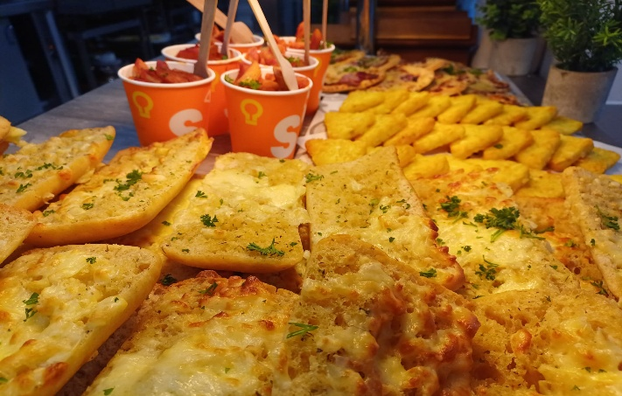
- How You Can Help:
To support a smooth canteen experience, please encourage your children to:
- Keep their catering account topped up in advance, allowing 24 hours for payments to clear.
- Look at the menu ahead of time so they know what they’d like to order.
- Join the queue early at break and lunchtime to ensure they have enough time to be served.
- Encourage your child to go for the main meal and pudding or fruit or water, which is not only the most nutritional way to eat with us but the best value for money too! All for £3 daily.
- We also offer daily meal deals again all set at £3, and these range from jacket potato with two topping, 12oz pasta pots, sub rolls and our main meals all served with dessert of the day or a piece of fruit or a bottle of plain water- again all for £3.
We are committed to creating a positive and enjoyable dining experience for all students, and we appreciate your support as we refine our systems and respond to feedback.
Warm regards,

The IFG Team

